HOW TO BUILD A "BULLETPROOF" VW TRANSAXLE
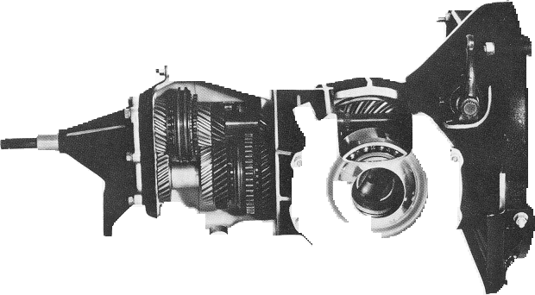

A few words of advice are offered here to help anyone making decisions on which parts to buy for rebuilding or "bulletproofing" a VW transaxle. Generally speaking, most VW transaxle cases, be they swing axle or IRS types, lend themselves beautifully to the Corvair engine swaps described in this catalog in addition to the kind of hop-ups being performed today. This holds true for any off road or street application; be it out-and-out com- petition such as Baja, a windy cruise over Glamas sand dunes or a family sight-seeing jaunt in the old Kombi.
From a professional point of view, most of today's tranny rebuilders prefer to use the swing axle trans case of '65 through '68 vintage. For that matter, the later IRS (independent rear suspension) cases have become quite popular and are considered excellent bulletproofing material. In addition to these you'll find the '72 sedan swing axle model to be ideal because it features an oversize clutch shaft. These cases share one common feature. In their stock form they come equipped with side plates which feature C-ring sealing around the critical perimeter of the final drive section. If you were to consider nothing else, this one factor should not be overlooked when deciding on a transaxle.
The mixing and matching of parts from the various transaxles is common practice and generally doesn't cause any difficulty. The thing to keep in mind here, however, is that certain combinations, though workable, are not as beneficial as others. For example, low gear from an early tranny ('61-'63) will fit into just about any VW swing axle case yolj care to name. But, dependability is afar more worthwhile consideration than fit or availability. For example, if you were to put an early low gear unit in any trans expected to withstand the punishment of wheelstanding or Ascot competition, it would only be a question of time before trans failure put you out of action.
Making minor improvements now while you are going through the drivetrain will payoff in the long run. Consider things such as replacing stock 3rd and 4th gear Woodruff keys with our heat treated keys. Specifically, stock keys holding 3rd and 4th gears in place on '67 and earlier pinion shafts are soft and should always be replaced with Crown's hardened 3rd and 4th Gear Keys #5207.. Also note that 3rd and 4th gears are driven by synchro tooth rings which are merely pressed into place. Whether you use our high strength close ratio gears #5047/5048 or retain stock gears, we strongly suggest that you have these assembled gears tack welded to the synchro hubs. Three or four %-inch long heliarc tack welds are sufficient.
And be sure to have the inside diameter surfaces honed to restore proper shaft tolerances.
The sleeve washer and shim arrangement between 3rd and 4th gears on the pinion shaft in stock pre-'67 transaxles is replaced with Crown's #5012 8eCu washer and spacer set. This will hold things securely in place on the pinion shaft. Moving along to 2nd gear, we find that stock transaxles are equipped with a brass shift fork for Ist to 2nd gear. This unit tends to bend and flex and occasionally break during hard shifting into 2nd (such as at the drags). Crown's heavy duty #5224 high-strength shift forks eliminate this problem.
In the final drive section we find that the stock VW differential housing is too weak to hold up under heavy use. We also believe the stock housing is too flexible for maintaining -proper ring and pinion gear tolerances. Crown offers three different heavy duty differential units, the #5023 IRs-type, #50598 swing axle Super Diff, and the #5059C Super Racing Diff for all racing applications. Each of these Diff units provides two additional spider gears, making the total four, and there's the added security of the heavier casting itself. The ring and pinion gears themselves can be replaced with a stronger late sedan, Variant or bus set up, or a good after-market package, in whatever ratio you feel is best for your application. However, the use of our #5059C Super Racing Diff, plus a pair of either aluminum (#5063A) or steel (#50638) side covers will serve to strengthen your final drive section without ring and pinion replacement.
Stock VW side covers lack the tensile strength and sheer mass required in the final drive section to keep the bearing from deflecting, and this in turn allows the ring gear to oscillate away from full engagement with the pinion gear. This is why over-stressed stock VW boxes break ring gears. Though controversy rages over which is the best replacement side cover, aluminum or steel, one thing is certain. used in combination with either of Crown's 4-spider Diffs, the threat of ring gear failure is substantially reduced. The bulletproofing process doesn't end here. We have axle tube retainers (#5073) in split or one-piece models which are designed to replace stock stampings with heavy duty machined plates. We also supply the strongest forged axles obtainable. They come in sizes to suit your application regardless of trans year. Be sure to use our heavy duty temperature- resistant gasket set #5055 to permanently eliminate leaks and drips.
Our suggestion is that you carefully review the components illustrated throughout this section and decide which items your application requires

.

