CORVAIR TO VW ADAPTER KITS

CORVAIR ENGINE AND TRANSAXLE TO VW KIT

Here is an adapter kit for installing the Corvair engine and power train into a '68-'71 IRS VW bus. Allows you to use any
4-speed '61 through '65 Corvair transaxle and engine combination. Conversion is easily accomplished in but a few hours. Kit consists of short (right side) and long (left side) axle adapters (see inset photo) which couple the VW constant velocity joints to the Corvair transaxle; front mount bracket for transmission; fear engine support; miscellaneous hardware and full instructions including the blueprint for guiding you in trimming the engine compartment sheet metal.

No.5301 complete kit…………………24 lbs.
No.5301-1 right CV joint adapter……10 Ibs.
No.5301-2 left CV joint adapter……. 10 Ibs.

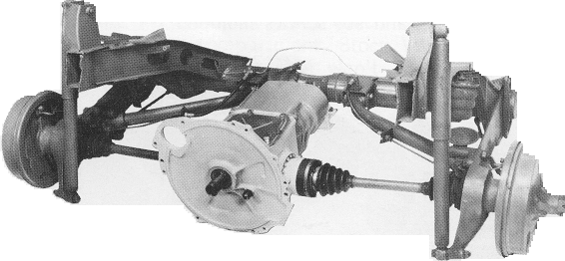

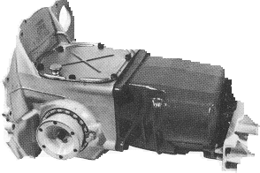
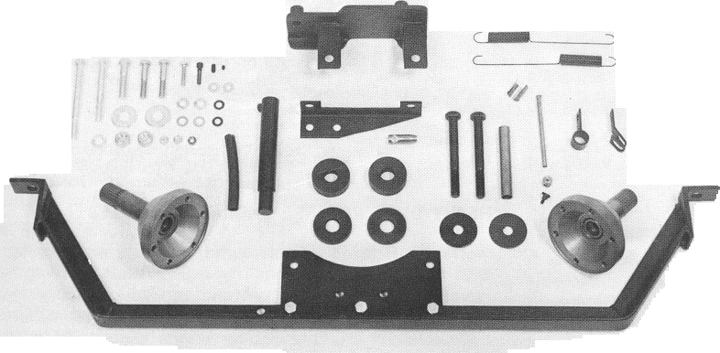

CORVAIR TO VW COMPONENTS

CORVAIR TO VW ENGINE ADAPTER
Precision cast and machined high strength aluminum
engine adapter is designed to match VW and Porsche transaxle contour and mate it to the Corvair engine. It does not require any sheet metal trimming to clear Shown at left. periphery of the adapter. Fits all VW transaxles up to 1976. This part is in kits 5101, 5102 and 5152. Includes hardware, gasket and seal.

CORVAIR TO VW GASKET AND SEAL SET

Precision die cut gasket sandwiches between Corvair engine and VW transaxle. Seal has die-formed steel ring and oil resistant Neoprene band which are vulcanized the to prevent separation.

No.5001-4-5lib

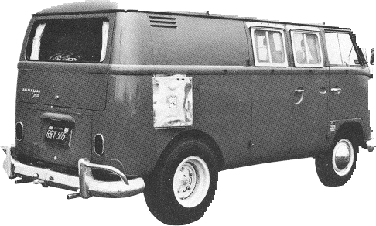
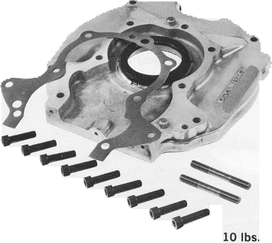
No.5001 engine adapter and hardware…..10 lbs.
No.5008 throttle linkage (couples VW
throttle wire to Corvair engine) …….1 lb.
No.5103 Corvair to VW Installation Manual
19

