CORVAIR TO VW ADAPTER KITS

Method No.2

REVERSED ENGINE

This method is required when you are going to use a reversed Corvair engine in '68 and later IRS trans-equipped VW, station wagon, automatic sedans or a 911/912 Porsche. The ring gear in these models cannot be reversed. You have a choice of 6-lb. aluminum, or, 16-lb. steel flywheel. Flywheel must be specified along with the style pressure plate your conversion requires -early (with release pad) or late (without release pad). You may order this kit with a Feramic Clutch Disc #50408 (see page 11). Add $20.00 to the price of the kit when ordering. In addition to this kit you will need a Reverse Corvair Engine Cam Kit (see below).

REVERSED ENGINE CORVAIR TO VW ADAPTOR KIT NO.5152
includes:
5001 engine adaptor
5004 A or B heavy duty pressure plate
(specify early "A.. or "B.. style-see page 10)
5005 clutch disc
5008 throttle linkage
-PLUS -
(the 6-volt flywheel of your choice)
5053A-L light (aluminum) flywheel 6-volt 109 teeth
5053A-H heavy (steel) flywheel 6-volt 109 teeth
-OR-
(the 12-volt flywheel of your choice)
5053B-L light (aluminum) flywheel 12-volt 130 teeth
5053B-H heavy (steel) flywheel 12-volt 130 teeth
No.5152A with light (aluminum) 6-volt flywheel……...26 Ibs.
No.51528 with heavy (steel) 6-volt flywheel………….36 Ibs
No. 5152C with light (aluminum) 12-volt flywheel….. 26 Ibs.
No.51520 with heavy (steel) 12-volt flywheel…….… 36 Ibs.
1

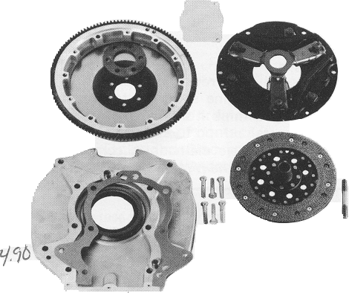
No.5152

See page 19 for Corvair engine and trans into '68 and later IRS bus conversion.

REVERSE CORVAIR ENGINE CAM KITS
The reversing of a Corvair engine is common practice these days and such an operation requires nothing in the way of unusual tools or techniques. The major requirement is replacing the stock camshaft with that of a Reverse Rotation camshaft. Obviously, this will have an effect on your firing order. But all you have to remember is that cylinder 1 remains in its original location. Stock firing order is 145236. With a reversed engine it becomes 163254. As you can see cylinder number 1 remains cylinder number 1. Crown no longer manufactures these cams but Crower Cams will remanufacture your existing Corvair Cam into a reversed cam. Call Crower Cams at (619) 422-1191 or write Crower Cams, 3333 Main Street, ,Chula Vista, California 92011 for full information.

GEARS FOR REVERSE CAMS
You will need to order No.5050-3-7 gears, washers and key. The hardened steel distributor drive gear (upper left) is a perfect fit on your distributor shaft. Large gear (upper right) is the bronze left hand drive oil pump gear. Cam thrust washer and Woodruff key also hardened. Order gears and washers individually or in sets.

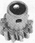
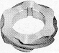

3 Missing items above in photo
No.5050-3 bronze cam gear only
No.5050-5 steel distributor drive gear only
No.5050-3-7 gears, washers & key

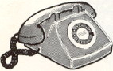
CALL THE SPEEDY ORDER LINE: 213.327.7670


SORRY, COLLECT CALLS NOT ACCEPTED
BANK AMERICARD VISA

