CORVAIR TO VW ADAPTER KITS

Is your problem with a standard VW a lack of power? Do you find yourself wanting more power on the high- way, and particularly if you are driving a bus? Hills are agonizing. ..you are frustrated and so are all motorists behind you. With a Crown Adaptor Kit you can power your stick shift VW transporter, sedan, Porsche, Karman Ghia or buggy with a Chevrolet Corvair engine. You can expect reliable results with Crown's quality kits and components. Each kit supplies you with everything necessary to make the swap a trouble-free installation.
All you have to do is shop around for a good or rebuild able Corvair engine. You'll be surprised how easily the Corvair snuggles up to your VW trans and leaves you a surprising amount of working room for tinkering with the engine when it is mounted in the car. Very little sheet metal cutting is required. Planning is the key to success with any engine swap. So take some measurements before you think it's time to start hacking away at the sheet metal.
There are two basic methods to compensate for the opposite rotation of the VW and Corvair engines. Both

are completely reliable arrangements. Your choice depends on: 1) Are you planning to remove and check or repair your VW transaxle? If so, use Method No.1. This is the reverse ring gear method; Or, 2) are you planning to rebuild your Corvair engine? If so, use Method No.2. This is the reverse engine method. It is also advisable when buying a transaxle to be aware of its year and the model VW it originally came from.
Electrical problems? There are none. The best and easiest way to handle the difference between the 12. volt Corvair system and the early 6-volt VW system is to install a 12-volt alternator and regulator and 12-volt bulbs throughout the car. A 10-watt resistor is spliced in series into the hot wire of the windshield wiper and a 25.watt resistor spliced into the transistor radio. The gauges work ok as is. Newer 12-volt VW ('67 and later) feature 12.volt systems so there are no changes required. Sorry, Crown conversion kits are not available for automatic transmissions. Additional items of interest are found in the "High Performance Corvair Parts"
section of this catalog.

_________________________________________________________________________________________________________________________________

Method No.1

REVERSED RING GEAR

This method is necessary to reverse the ring gear of all swing axle VWs to reverse the drive direction of the trans.
Use a 12.volt Corvair starter -this we do not supply. Available with 6.lb. aluminum, or 16.lb. steel flywheel. When ordering either the BASIC or DELUXE kits, you must specify which (flywheel) you require. If you order No. 5101A or 5102A you will receive a light aluminum flywheel. See page 20. If you order No. 5101B or 5102B you will receive a heavy steel flywheel. See page 20. You may order either kit with a Feramic Clutch Disc #5040B (see page 11.) Add $2000 to the price of either kit when ordering.

BASIC CORVAIR TO VW ADAPTOR KIT NO.5101
This kit is offered for those who prefer to supply their own clutch assembly.
includes:
5001 engine adapter
5002 offset starter adaptor & bushing set
5003 12-volt Corvair flywheel, 127 teeth (aluminum or steel)
5008 throttle linkage

No. 5101A Kit comes with aluminum flywheel ………16 Ibs.

No.5101B Kit comes with steel flywheel…………….. 20 Ibs.

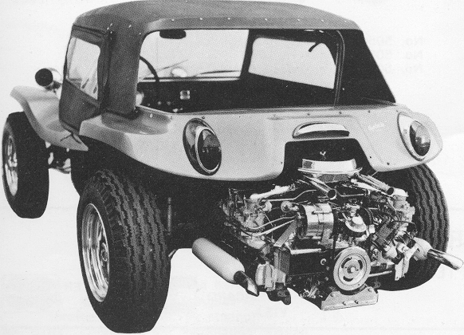

DELUXE CORVAIR TO VW ADAPTOR KIT NO.5102

The advantages of this kit are that when you have installed it, the complete drivetrain is overhauled: Note: You must specify aluminum or steel flywheel; adaptor plus, early or late pressure plate.

includes (as shown)
5001 engine adapter
5002 offset starter adapter & bushing set
5003 12.volt Corvair flywheel, 127 teeth (aluminum or steel)
5004 A or B heavy duty pressure plate
(specify early "A" or late .'B" style-see page 10) 5005 clutch disc
5008 throttle linkage
5012 spring washers & spacer kit for 3rd & 4th gears
No. 5102A Kit comes with aluminm flywheel……………….. 26 Ibs.

No.5102B Kit comes with steel fylwheel……………………..36 lbs.

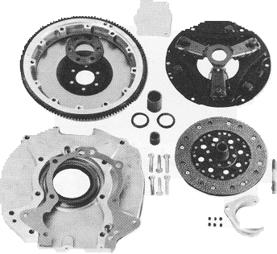

.

No.5102

